Name
Date
Class
Test
- Complete with: illusion, miniature, nurse, parade, gravity, become
- Robots will soon ____________part of everyday life.
- There is zero________________ in space.
- Willard Wigan makes ___________________ sculptures.
- A good ______________ needs to be caring, patient and responsible.
- The festival included a bright street _____________.
- People who see one picture inside another are experiencing an optical___________________.

- Complete the sentences with the correct comparative and superlative forms of adjectives:
- She’s ______________(tall) in her class.
- Her sister is __________________(talented) than she.
- That was _____________(bad) film I’ve ever seen.
- Which of these pictures do you think is ________________(good)?
- This train leaves _____________(late) than the first one.

- Complete the sentences with the correct passive form of the verbs:
- The rubbish bins ___________________________ (empty) every week.
- This book ____________________________(return) to the library yesterday.
- The Eiffel Tower _________________________(build) in 1898.
- Your letter ____________________(send) tomorrow.
- All the tickets _______________________(already/sell out).

- Read the text and mark statements TRUE (T), FALSE (F) or NOT STATED (Ns)

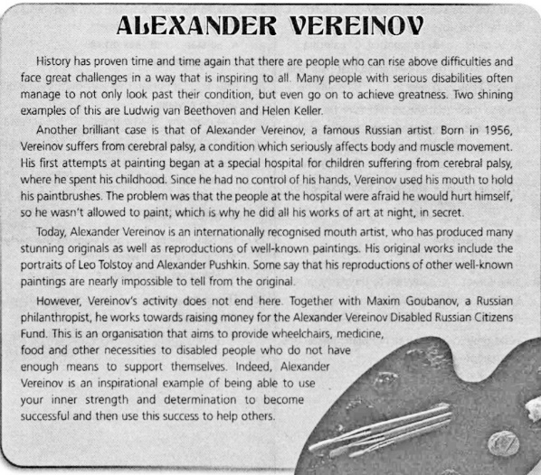

1. Beethoven and Keller weren’t born disabled. ______
2. Vereinov only painted at night because they didn’t let him paint during the day. ______
3. Alexander Vereinov started painting at an early age. ______
4. Vereinov gives part of his money to charities for the disabled. ______
5. His copies of famous art works are extremely accurate. ______
5. You have received the letter from your English-speaking friend Alex.
… I really loved the concert! What kind of music do you enjoy? Have you ever been to a concert? What artist would you really like to see perform live?
Write back soon,
Alex
Write him a letter and answer his 3 questions. (80-100 words)

